Template for Evidence(s)
UI GreenMetric Questionnaire

University : ...
Country : ...
Web Address : …

[6] Education and Research (ED)
SAMPLE

[6.8] Number of lecturers and researchers on campus in one year period

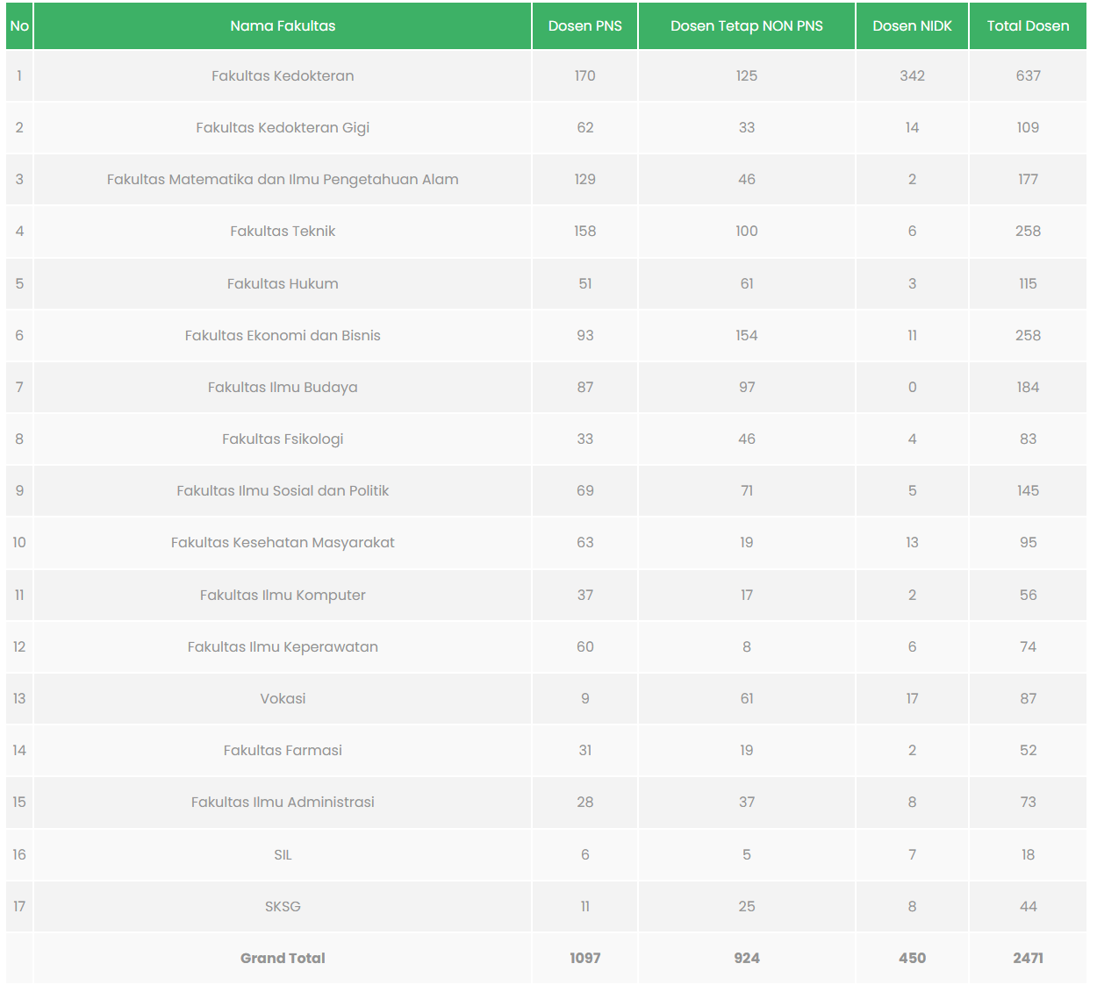
Examples of number lecturers and researchers (Universitas Indonesia, Indonesia)

Description:
(Please describe number of lecturers and researchers on campus in one year period. The following is an example of the description. You can describe more related items if needed.)

Additional evidence link (i.e., for videos, more images, or other files that are not included in this file):

